EX. NO: 2

IMPLEMENTATION OF PLAYFAIR CIPHER
Aim:
To write a C program to implement the Playfair Substitution technique.
ALGORITHM:
STEP-1: Read the plain text from the user.
STEP-2: Read the keyword from the user.
STEP-3: Arrange the keyword without duplicates in a 5*5 matrix in the row order and
fill the remaining cells with missed out letters in alphabetical order. Note that
„i‟ and „j‟ takes the same cell.
STEP-4: Group the plain text in pairs and match the corresponding corner letters by
forming a rectangular grid.
STEP-5: Display the obtained cipher text.
Program:
#include <stdio.h>
#include <string.h>
#include <ctype.h>
char keyTable[5][5];
// Generate Playfair key table
void generateKeyTable(char key[]) {
int used[26] = {0};
int i, j, k = 0;
used['J' - 'A'] = 1; // I and J are treated as same
for (i = 0; key[i] != '\0'; i++) {
char ch = toupper(key[i]);
if (ch == 'J') ch = 'I';

if (!used[ch - 'A']) {
keyTable[k / 5][k % 5] = ch;
used[ch - 'A'] = 1;
k++;
}
}
for (i = 0; i < 26; i++) {
if (!used[i]) {
keyTable[k / 5][k % 5] = 'A' + i;
k++;
}
}
}
// Find position of a letter
void findPosition(char ch, int *row, int *col) {
if (ch == 'J') ch = 'I';
for (int i = 0; i < 5; i++) {
for (int j = 0; j < 5; j++) {
if (keyTable[i][j] == ch) {
*row = i;
*col = j;
return;
}
}
}
}
int main() {
char key[50], text[100];
int i;
printf("Enter Key: ");
scanf("%s", key);
printf("Enter Plain Text (uppercase, no spaces): ");
scanf("%s", text);
generateKeyTable(key);
printf("\nKey Table:\n");
for (i = 0; i < 5; i++) {
for (int j = 0; j < 5; j++)
printf("%c ", keyTable[i][j]);
printf("\n");
}
printf("\nEncrypted Text: ");
for (i = 0; text[i] != '\0'; i += 2) {
char a = toupper(text[i]);
char b;
if (text[i + 1] == '\0')
b = 'X';
else
b = toupper(text[i + 1]);
int r1, c1, r2, c2;
findPosition(a, &r1, &c1);
findPosition(b, &r2, &c2);
if (r1 == r2) {
printf("%c%c",
keyTable[r1][(c1 + 1) % 5],
keyTable[r2][(c2 + 1) % 5]);
}
else if (c1 == c2) {
printf("%c%c",
keyTable[(r1 + 1) % 5][c1],
keyTable[(r2 + 1) % 5][c2]);
}
else {
printf("%c%c",
keyTable[r1][c2],
keyTable[r2][c1]);
}
}

return 0;
}
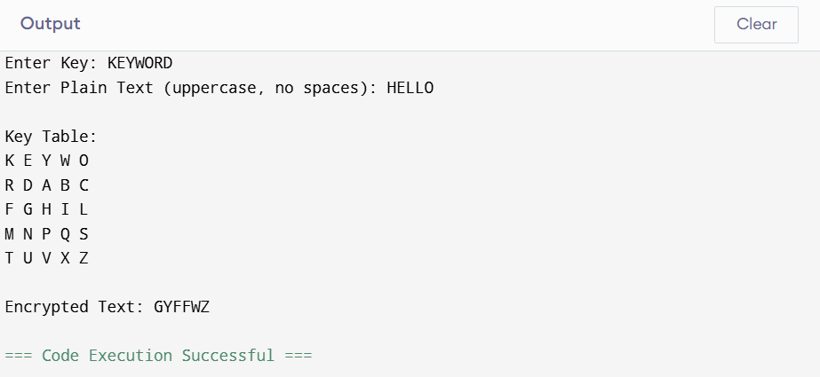

Result:
Thus the Playfair cipher substitution technique had been implemented successfully.

